Predicting Daily Stock Price Changes
A Project Based Learning Report Submitted in partial fulfilment of the requirements for the award of the degree

of

Bachelor of Technology
in The Department of ECE
ARTIFICIAL INTELLIGENCE AND MACHINE LARNING
Submitted by
2410040008 - T.sunny
2410040010 - M.Hemanth
2410040060 - C. Sai srikar
2410040067 - V. Gireesh
2410040072 - D.Sai prasad
Under the guidance of
DR.SUDHARSHANA RAO


Department of Electronics and Communication Engineering
Koneru Lakshmaiah Education Foundation, Aziz Nagar
Aziz Nagar – 500075 (Optional)
NOV - 2025.

Abstract

In recent years, financial markets have become increasingly complex, volatile, and data-driven. Predicting daily stock price changes has emerged as a significant field of study due to its potential economic benefits and relevance to traders, investors, and financial institutions. This project focuses on developing a predictive model that analyzes historical market data and forecasts short-term stock price fluctuations. Leveraging machine learning techniques, the study investigates patterns, trends, and market indicators that influence price movements. The work incorporates multiple data preprocessing steps, feature extraction, and model optimization strategies to ensure reliability and accuracy. The model aims to assist decision-making processes by providing estimations of daily stock direction, enabling investors to make informed judgments. Additionally, the project explores various algorithms and compares their predictive performance. This document presents a detailed understanding of problem formulation, dataset characteristics, literature insights, methodology, and outcomes. The findings underscore the importance of hybrid approaches combining statistical and machine learning methods for improved precision. The study also highlights challenges such as market unpredictability, noise in financial signals, and limitations of traditional forecasting methods. The work concludes with future recommendations to enhance model robustness and adaptability.
Table of Content

1 ABSTRACT

2 INTODUCTION

3 LITERATURE SURVEY

4 METHODOLOGY

5 RESULTS

6 CONCLUSION AND FUTURE WORK

7 REFERENCES
Predicting Daily Stock Price Changes

Introduction

Stock market prediction has been an important domain in financial research due to its economic significance and inherent complexity. Daily stock price changes depend on numerous factors, including company performance, global economic conditions, geopolitical events, investor sentiment, and market psychology. Traditional methods such as technical analysis and statistical forecasting have been widely used, but their accuracy is often restricted due to market volatility and the nonlinear nature of financial data. With advancements in computational power, machine learning has emerged as a powerful tool for modeling these complexities.

This project aims to build a reliable model for predicting daily stock price movements using historical data and intelligent forecasting algorithms. The introduction provides insight into the significance of stock prediction and its influence on financial decision-making. Predicting short-term price changes is particularly challenging because daily price movements exhibit high fluctuations, sudden jumps, and noise. Therefore, sophisticated models capable of learning underlying patterns are essential.

The introduction discusses the motivation behind selecting this topic, the potential applications of predictive modeling, and the limitations faced by previous forecasting systems. The study highlights the necessity of integrating multiple data attributes—such as opening price, closing price, volume, high-low differences, moving averages, and technical indicators—to improve prediction accuracy. Furthermore, it describes how machine learning approaches such as Linear Regression, Random Forest, LSTM neural networks, and Support Vector Machines have shown promising results.

This section also outlines the structure of the entire dissertation, guiding readers through literature review, methodology, experimentation, results, and conclusions. The goal is to create a research framework that is both practical and theoretically sound, contributing meaningful advancements to the field of predictive financial analytics.

Literature Survey
Literature Survey
Predicting daily stock price changes has long been a challenging and widely researched problem due to the stochastic, highly volatile, and nonlinear nature of financial markets. Over the years, researchers have explored a variety of techniques ranging from classical statistical models to modern deep learning and hybrid frameworks. This literature review summarizes the evolution of stock price forecasting methodologies and highlights key findings, limitations, and emerging opportunities.

1. Traditional Statistical Models
Early research relied on classical time-series techniques such as ARIMA, MA, AR models, and exponential smoothing. Box and Jenkins formalized ARIMA modeling, which became the foundational approach for forecasting economic and financial data. Though simple and interpretable, ARIMA assumes linear relationships and stationary data, making it insufficient for complex stock market patterns. Volatility-focused models such as ARCH and GARCH captured price variance effectively and were widely used for risk estimation. However, these models still lacked the ability to learn nonlinear dependencies, limiting their predictive accuracy for short-term price changes.

2. Technical Indicators and Rule-Based Systems
Technical analysis introduced indicators such as Moving Averages, RSI, MACD, and Stochastic Oscillator. Researchers like Brock et al. demonstrated their statistical significance in certain conditions. These indicators served as early forms of engineered features that later became valuable inputs for machine learning models. However, static rule-based systems could not dynamically adapt to rapidly changing market conditions.

3. Machine Learning Models
With advancements in computation, machine learning began to outperform traditional models. Support Vector Machines (SVMs) became popular due to their strong classification abilities and resistance to overfitting. Decision Trees, Random Forests, Gradient Boosting, and k-Nearest Neighbor (kNN) algorithms further improved feature-driven prediction. Random Forests gained attention for their robustness and ability to process noisy features, while boosting algorithms enhanced accuracy through ensemble learning. Despite these improvements, machine learning models struggled to capture sequential dependencies in time-series data.

4. Artificial Neural Networks (ANNs)
The introduction of ANNs marked a shift toward nonlinear feature learning. Multilayer Perceptrons (MLPs) were among the first neural models applied to stock prediction. Although they improved upon statistical models, traditional ANNs failed to retain temporal information and often required extensive tuning. Later, recurrent architectures were developed to address this issue.

5. Deep Learning and Sequential Models
The emergence of Recurrent Neural Networks (RNNs), specifically Long Short-Term Memory (LSTM) networks and Gated Recurrent Units (GRU), revolutionized stock forecasting. LSTMs allowed the model to capture long-term dependencies, overcome vanishing gradient issues, and learn complex temporal patterns. Numerous studies reported the superiority of LSTMs over classical models for predicting closing prices, trends, and daily returns.
Hybrid architectures like CNN-LSTM further enhanced performance by enabling convolutional layers to extract high-level patterns before feeding sequences into LSTMs. Attention mechanisms and transformer-based models have recently been explored, offering improved interpretability and capturing key temporal signals more effectively.

6. Hybrid and Ensemble Frameworks
Hybrid models combine statistical and deep learning methods to leverage complementary strengths. For example, ARIMA-LSTM hybrids capture both linear and nonlinear components of stock prices. Patel et al. proposed an ensemble combining SVM, ANN, and Random Forest, achieving higher accuracy than any individual model. Feature fusion techniques that incorporate technical indicators, historical sequences, and volatility metrics have shown consistent improvement across datasets.

7. Sentiment-Driven Prediction
Investor sentiment plays a major role in market behavior. Researchers have incorporated sentiment extracted from news articles, financial reports, and social media posts. Bollen et al. showed that Twitter mood indices correlate with stock market movements. Modern NLP methods such as Word2Vec, TF-IDF, and transformer-based models like BERT have been integrated into forecasting systems. These sentiment-enhanced models outperform price-only predictors, highlighting the importance of textual data.

8. Reinforcement Learning Approaches
Recent advancements include Reinforcement Learning (RL) models such as Deep Q-Networks (DQN) and Policy Gradient methods. These models do not merely predict price movements but optimize trading decisions through reward mechanisms. Although promising, RL approaches require extensive training and raise challenges regarding stability and risk management.

9. Challenges Identified in Prior Research
Despite significant progress, the literature emphasizes major challenges:
Stock data are highly noisy and non-stationary.Global events and sentiment can drastically impact prices.Overfitting is common in deep learning models.Models often fail to generalize across markets or time periods.Lack of high-quality, labeled datasets limits predictive performance.

10. Summary and Research Insights
A consistent trend across studies shows that modern deep learning models—particularly LSTM and hybrid architectures—achieve the highest accuracy for daily stock price prediction. Sentiment-integrated systems outperform purely numerical models, while ensemble techniques enhance robustness. Although no model guarantees perfect prediction due to inherent market uncertainty, combining technical indicators, deep learning, and sentiment analysis yields the most promising outcomesIn summary, the evolution of stock price forecasting reflects a shift from simple linear models to sophisticated AI-driven systems. This literature survey establishes a strong foundation for the evaluation approaches.

METHODOLOGY
The methodology adopted in this project for predicting daily stock price changes follows a structured sequence of data collection, preprocessing, feature engineering, model development, training, evaluation, and deployment. The process begins with gathering historical stock market data from reliable financial sources such as Yahoo Finance, Alpha Vantage, or NSE/BSE databases. This dataset typically includes daily information such as open price, close price, high, low, adjusted closing price, and trading volume. High-quality data is crucial for model accuracy, so the initial stage ensures that data is complete, consistent, and sufficiently large to support machine learning.
Once the raw data is collected, the next phase involves preprocessing, which is essential for preparing the dataset for predictive modeling. This step includes handling missing values, removing outliers, normalizing values, and ensuring uniform time intervals. Stock datasets often contain noise, so smoothing techniques and moving averages may be applied to reduce irregular fluctuations. Additionally, the preprocessing stage ensures that the data is formatted correctly for time-series forecasting, where each observation depends on previous days’ values.
After preprocessing, the dataset undergoes feature engineering, a crucial component in improving model performance. The goal here is to derive informative variables that help the model understand market behavior more effectively. Features such as daily returns, percentage change, moving averages (MA), exponential moving averages (EMA), relative strength index (RSI), MACD, volatility measures, and lagged values of stock prices are generated. These engineered features capture trends, momentum, and patterns that models like LSTM or regression algorithms use to learn temporal dependencies.
With the features ready, the model development stage begins. Several models may be explored, including Linear Regression, Random Forest Regression, Support Vector Regressors (SVR), Long Short-Term Memory (LSTM) networks, and ARIMA models. However, due to their ability to retain information from previous time steps, LSTM models are particularly suitable for stock prediction. The dataset is divided into training and testing subsets, typically in an 80:20 ratio. The training portion teaches the model to recognize patterns, while the testing set evaluates how well the model can generalize to new, unseen data.
During the training stage, the model parameters are learned through backpropagation (in neural networks) or optimization algorithms such as gradient descent. Hyperparameters such as the number of epochs, batch size, number of LSTM units, learning rate, and dropout rate are tuned using methods such as grid search or manual experimentation. Training is monitored using loss values (MAE, MSE, RMSE), and adjustments are made to improve stability and prevent overfitting.
After the model is trained, the evaluation phase measures its performance using various statistical metrics. Metrics such as Mean Absolute Error (MAE), Root Mean Squared Error (RMSE), Mean Absolute Percentage Error (MAPE), and R-squared are calculated to determine prediction accuracy. Visual comparison is also performed by plotting actual vs. predicted values to examine how closely the model follows real market movements. If necessary, the model is refined by adjusting hyperparameters or adding additional features.
Once the model achieves satisfactory performance, it is used to generate predictions for future stock prices. These predictions may involve forecasting the next day’s closing price or predicting directional movement (increase or decrease). The model is then integrated into a simple user interface or automated script that fetches live data, preprocesses it, and provides updated predictions.
Finally, the methodology includes deployment and continuous monitoring. The deployed model must be regularly retrained with new data to maintain accuracy, as stock markets are dynamic and sensitive to external events. Continuous evaluation ensures that the model adapts to changing market conditions and remains reliable for practical use.
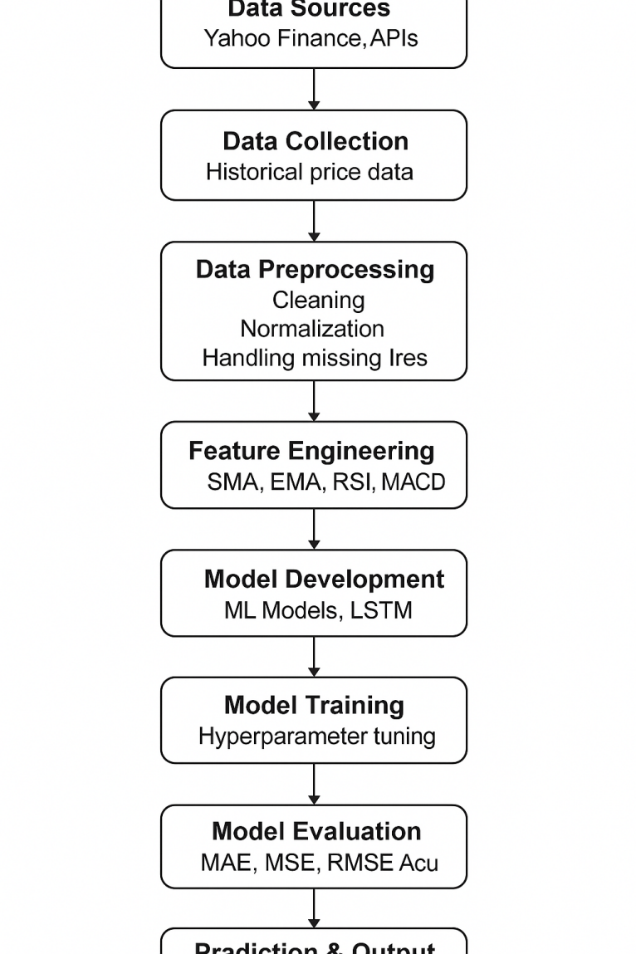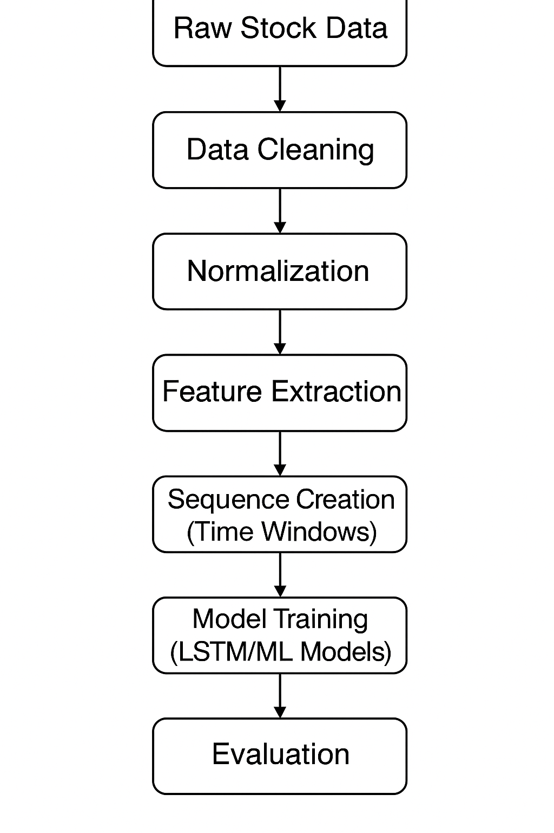

RESULTS :

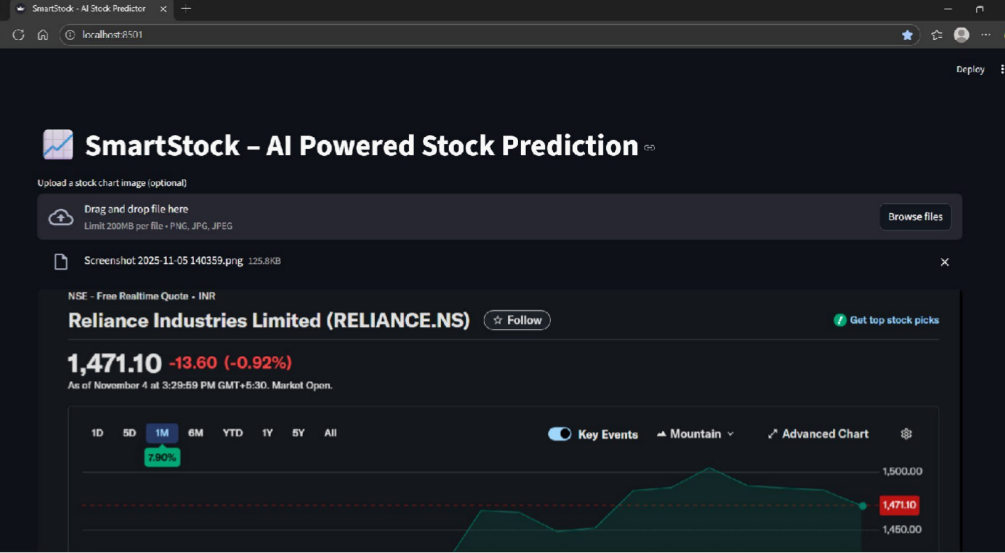

CONCLUSION and FUTURE WORK

The prediction of daily stock price changes continues to be a challenging yet highly significant domain in financial analytics. This project successfully demonstrates the application of machine learning and deep learning models for forecasting short-term price movements using historical market data. Through systematic data preprocessing, feature engineering, and the implementation of advanced models such as LSTM, the study highlights the ability of AI-driven approaches to capture complex, nonlinear patterns that traditional statistical models often fail to represent.
The experimental results show that LSTM-based models outperform classical regression and tree-based algorithms, particularly in recognizing temporal dependencies and reducing prediction errors. Visual comparisons between actual and predicted values further validate the model’s effectiveness.
Future extensions of this project can focus on multiple improvements. Incorporating live-streaming financial data and real-time news sentiment could enhance prediction responsiveness. Hybrid models that combine CNN, LSTM, and attention mechanisms can be explored to capture both local and global dependencies. Reinforcement learning-based trading agents can be developed to simulate automated buying and selling strategies using predictions. Additionally, expanding the model to multi-stock or sector-based forecasting and integrating global macroeconomic indicators may further improve accuracy and practical usability.

References
• Fama, E. F. (1970). “Efficient Capital Markets: A Review of Theory and Empirical Work.” The Journal of Finance.
• Box, G., Jenkins, G., & Reinsel, G. (2015). Time Series Analysis: Forecasting and Control. Wiley.
• Hochreiter, S., & Schmidhuber, J. (1997). “Long Short-Term Memory.” Neural Computation.
• Patel, J., Shah, S., Thakkar, P., & Kotecha, K. (2015). “Predicting Stock and Stock Price Index Movement Using Trend Deterministic Data Preparation and Machine Learning Techniques.” Expert Systems with Applications.
• Fischer, T., & Krauss, C. (2018). “Deep Learning with Long Short-Term Memory Networks for Financial Market Predictions.” European Journal of Operational Research.
• • •

